**HIVE HQL HANDSON**

1.Creating first table

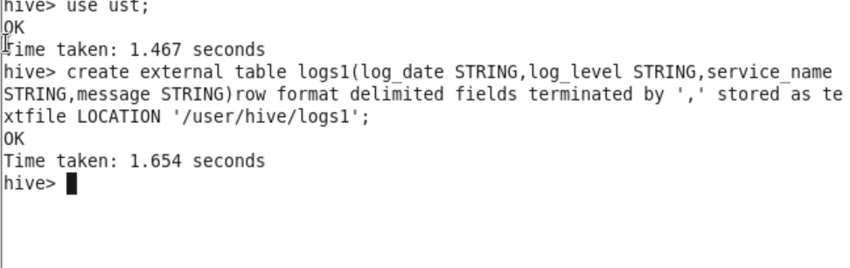

2.Loading data into the table

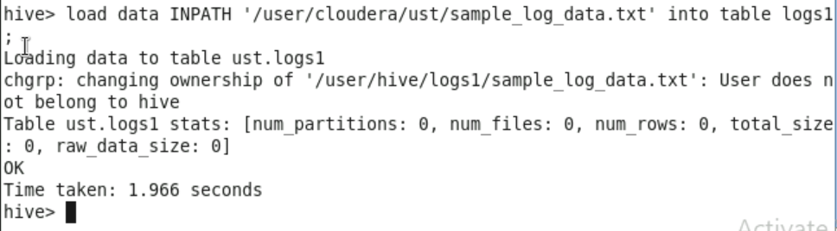

3. Printing sample records

4.Creating next table for partition

5.Loading data from first table to partitioned table

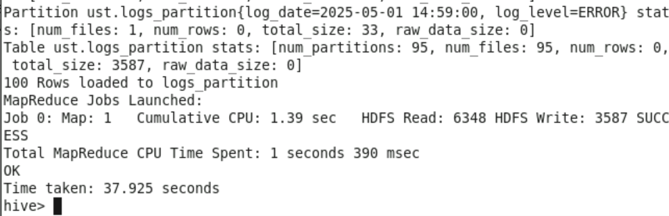

6.View all logs

7.Count total logs

8.Count logs by log level

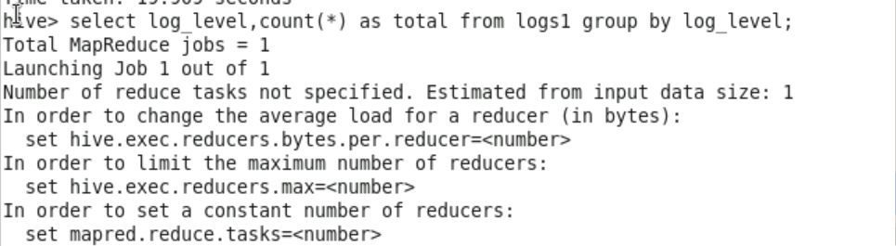

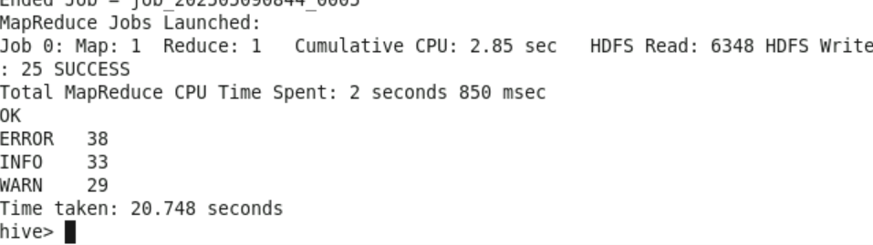

9.Count error logs per service

10.filter logs by date

11.Create view for error logs

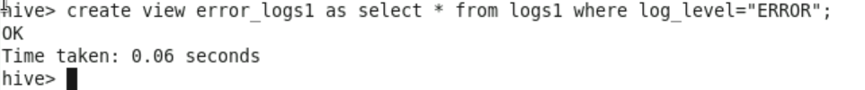

Results in UI:

